**Shanto-Mariam University of Creative Technology**



**Course Title: Project II**

**Course Code: ICT-3204**

**Project Proposal**

Prepared By:

Md. Latifur Rahman Ratul

(ID-213071023)

Sakhawat Hossain Mahin

(ID-213071026)

Semester: 6th

Batch No. 28

Submitted To:

Ms. Anika Bushra

Lecturer, Dept. of CSE

& CSIT, SMUCT

Introduction:

Chatbird is a versatile Flutter-based chat application designed to deliver a seamless and engaging messaging experience. The app boasts an array of features, including real-time messaging, multimedia sharing, and status updates. Developed with Flutter, the app ensures a consistent user interface across various platforms.

The Catbird application is a Flutter-based real-time messaging platform designed

to provide users with an intuitive and feature-rich communication experience. With

functionalities inspired by popular messaging chatting apps, catbird includes a

robust backend powered by Socket.IO, MongoDB, and Node.js.

1. Description:

2.1. Features   
  
2.1.1 Messaging Capabilities

* Real-time Messaging: Users can engage in real-time one-to-one messaging, fostering instant communication.
* Multimedia Sharing: The app supports sending and receiving photos and videos, enhancing the user experience.

2.1.2 Media Capture

* Camera Integration: Chatbird features a built-in camera functionality, allowing users to capture photos and record videos directly within the app.
* Gallery Access: Users can choose images and videos from their device's gallery for easy sharing.

2.1.3 Call Pages UI

* Intuitive Call Pages: The app provides a user-friendly interface for handling calls, ensuring a smooth calling experience.
* Call Status Indicators: Clear indicators for call status (incoming, outgoing, missed) improve user awareness.

2.1.4 Status Updates

* Status Page: Users can set and view status updates, providing a way to share their current activities or thoughts.
* Status Media Sharing: The app allows users to attach media to their status updates.

2.2 Technology Stack

2.2.1 Frontend

* Flutter Framework: The app leverages Flutter for cross-platform development, ensuring a consistent look and feel on both iOS and Android devices.
* Dart Programming Language: Dart is used as the primary language for developing the app's frontend.

2.2.2 Backend

Real-Time Messaging

* Socket.io: Chatbird's backend is powered by Socket.io, enabling real-time communication between clients. Socket.io provides a reliable and scalable solution for handling instant messaging.

Database

* MongoDB with Mongoose: MongoDB serves as the database for Chatbird. Mongoose, an ODM (Object Data Modeling) library for Node.js, is employed for seamless interaction with MongoDB, ensuring data consistency and integrity.

Authentication

* Firebase Authentication: User authentication is securely managed using Firebase Authentication services. Firebase Authentication enhances the app's security by providing robust and scalable user identity management.

Cloud Firestore:

* Firebase Cloud Firestore: For additional data storage needs, Firebase Cloud Firestore can be integrated. Firestore is a NoSQL cloud database that allows for flexible and scalable data storage, making it suitable for chat applications with varying data structures.

Hosting and Deployment

Node.js: The backend server is developed using Node.js, providing an efficient and event-driven runtime for building scalable network applications.

Firebase Hosting: Firebase Hosting can be utilized to deploy and host the backend server, ensuring a reliable and secure infrastructure.

Workflow with figure:

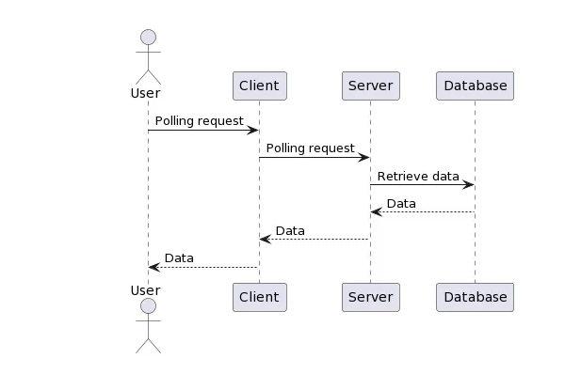

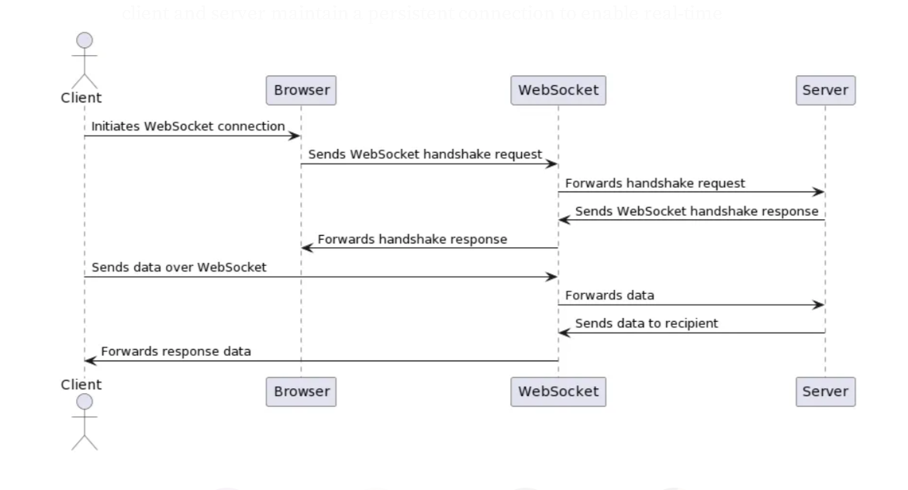

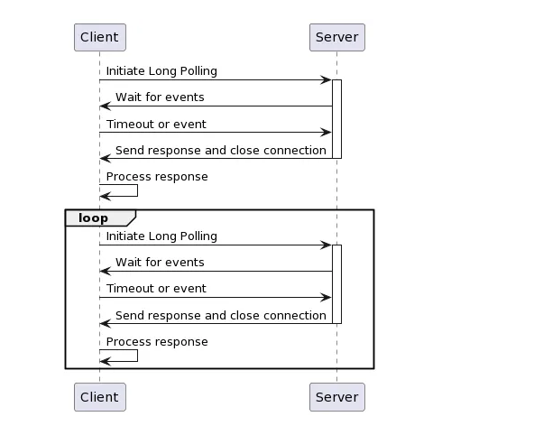

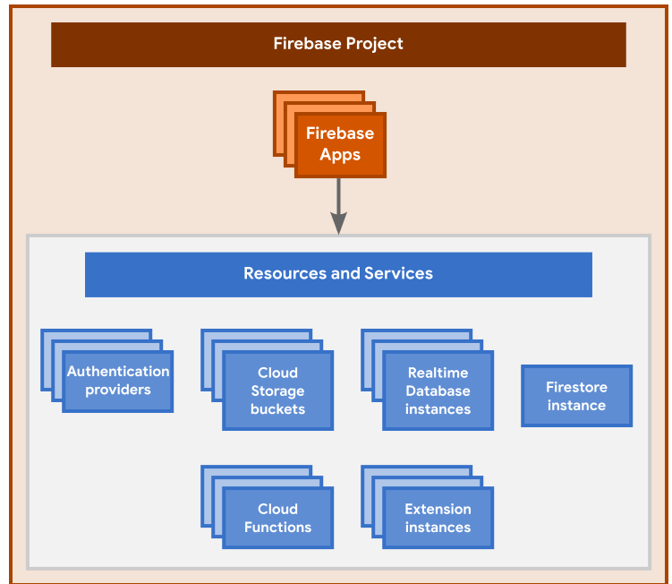

Input & Output with necessary screenshot:

Tech & Platform:

Conclusion

Chatbird stands as a sophisticated and feature-rich chat application that seamlessly integrates real-time messaging, multimedia sharing, and call functionalities. The robust technology stack, including Socket.io for real-time communication and Firebase for authentication, ensures a reliable and engaging messaging solution. With additional options like Firebase Cloud Firestore for scalable data storage, Chatbird is well-equipped to meet the demands of modern chat applications.